**5.5 Defect Report / Test Log**

* **Objective**

The objective of the Defect Report / Test Log is:

* To systematically record any defects, errors, or deviations encountered during the execution of planned test cases.
* To monitor and track the status of identified defects from discovery through resolution.
* To provide a clear, organized, and traceable record of testing activities, including executed test cases, their outcomes, and corresponding defect details.
* To ensure that all critical and major defects are identified, addressed, and resolved prior to production deployment.
* **Scope**

This section covers the logging and reporting of defects identified during:

* Unit Testing (where applicable)
* Integration Testing
* System Testing
* Acceptance Testing

It applies to all modules and functionalities of the Trimurti-Online Grocery Store project.

* **Defect Report Format**

A Defect Report is maintained for any failed or partially successful test cases.

|  |  |  |  |  |  |  |
| --- | --- | --- | --- | --- | --- | --- |
| **Defect ID** | **Test Case ID** | **Module** | **Defect Description** | **Severity** | **Status** | **Remarks** |
| DEF-001 | TC-PM-002 | Payment | Payment verification fails silently during successful payment processing | Critical | Open | Affects course enrollment |
| DEF-002 | TC-UM-010 | User Management | Session timeout not properly handled | Critical | Open | Users unexpectedly logged out |
| DEF-003 | TC-CM-006 | Course Management | Course deletion leaves orphaned lecture data in database | Major | Open | Data integrity issue |
| DEF-004 | TC-PT-005 | Progress Tracking | Progress not syncing correctly across multiple devices | Major | Open | User experience impact |
| DEF-005 | TC-CERT-003 | Certificate | Certificate verification system not validating expired certificates | Major | Open | Security concern |

* **Defect Severity Levels**

|  |  |
| --- | --- |
| Severity Level | Description |
| Critical | Application crash, data loss, or security vulnerability. Must be fixed immediately. |
| Major | A defect that affects core functionalities but has a workaround. Needs to be fixed before release. |
| Minor | Cosmetic issues or defects with limited operational impact. Can be addressed in future updates. |

* **Defect Life Cycle**

1. New – Defect reported by QA tester.
2. Open – Defect validated and assigned to a developer.
3. In Progress – Developer working on resolving the defect.
4. Resolved – Defect fixed and delivered for re-testing.
5. Closed – Defect successfully verified and closed by the tester.
6. Reopened – If the defect persists after being marked as resolved.
7. Deferred – Defect scheduled for future versions (if applicable).

* **Test Log Example**

|  |  |  |  |  |  |
| --- | --- | --- | --- | --- | --- |
| **Module** | **Total Test Cases** | **Pass** | **Fail** | **Defects Logged** | **Remarks** |
| User Management | 10 | 8 | 2 | 2 | 2 critical defects logged (Session timeout, Email verification) |
| Course Management | 9 | 7 | 2 | 2 | 2 major defects logged (Course deletion, Lecture addition) |
| Payment Module | 10 | 8 | 2 | 2 | 2 critical defects logged (Payment verification, Duplicate payment) |
| Progress Tracking | 10 | 9 | 1 | 1 | 1 major defect logged (Progress sync) |
| Certificate Module | 9 | 8 | 1 | 1 | 1 major defect logged (Certificate verification) |
| Admin Management | 7 | 6 | 1 | 1 | 1 major defect logged (User role update) |

* **Deliverables**

The following artifacts will be produced and maintained as part of this section:

* Test Execution Logs
* Defect Report Logs
* Defect Summary Reports
* Test Summary and Closure Report
* Test logs and defect reports are reviewed and approved before final project sign-off.

**CHAPTER 6**

**LIMITATIONS OF PROPOSED SYSTEM**

1. **Initial Setup Requires Time and Effort:** Deploying the platform is not instantaneous. It requires time to install dependencies, configure the system, upload content, and assign user roles. In the absence of a dedicated technical team, the setup process may be delayed or require additional support.
2. **No Integrated Test or Quiz Functionality**: The current version focuses on delivering video lectures, notes, and course materials. It lacks built-in features for assessments like quizzes or tests, and does not track student performance. These capabilities would need to be handled through separate tools or future development.
3. **Reliable Internet Connection is Necessary**: As the platform operates entirely online, students must have a stable internet connection to access video lectures or download materials. Users with limited or unstable connectivity may encounter issues, especially when streaming content.
4. **Manual Content Uploading**: Instructors and administrators must upload each file individually. There is no bulk upload or content scheduling system implemented yet, which can be time-consuming for educators managing large volumes of materials.
5. **Lack of Integration with External Systems**: The platform currently functions in isolation and does not integrate with external tools such as Zoom, Google Classroom, or existing college ERP systems. This may be inconvenient for institutions already using such platforms in their academic workflows.
6. **Dependence on Technical Support**: Like any digital system, the platform is susceptible to bugs, downtime, or server issues. Without technical personnel to resolve these promptly, users may experience disruptions or limited access.

**CHAPTER 7**

**PROPOSED ENHANCEMENTS**

1. **Integration of Quizzes and Assessments**: Incorporating quizzes, coding tasks, and assessments would enable students to test their understanding within the platform. This would also assist instructors in evaluating learning outcomes and student performance.
2. **Course Enrollment and Access Control**: A structured course enrollment mechanism would allow students to register for specific courses. This would also help instructors manage student groups more effectively and restrict content access based on enrollment.
3. **Interactive Discussion Forums or Q&A Sections**: Introducing community features like discussion boards or Q&A forums would foster collaboration between students and instructors, enhancing engagement and supporting peer learning.
4. **Third-Party Tool Integration**: Future versions could support integrations with platforms like Zoom for live sessions, Google Drive for resource storage, or existing institutional systems for attendance and grading management.
5. **Automated Notifications and Alerts**: Email and in-app notification systems could be implemented to keep users informed about new lectures, assignment deadlines, announcements, or system updates, improving communication and engagement.
6. **Mobile Application Development**: A dedicated mobile app for Android and iOS would allow students to access learning materials from any device, improving accessibility for those who prefer learning on-the-go.

**CHAPTER 8**

**CONCLUSION**

The E-learning Platform project has successfully delivered a comprehensive online learning management system built on the MERN stack (MongoDB, Express.js, React.js, Node.js). The platform features six core modules: User Management, Course Management, Payment Processing, Progress Tracking, Certificate Generation, and Admin Management, each designed with robust security measures and user-centric functionality. With a total of 55 test cases executed, the platform achieved an 81.82% pass rate, demonstrating strong reliability across its features. The system implements secure authentication using JWT, role-based access control, and real-time progress tracking, while maintaining a responsive design for multiple devices. While the platform shows promising results, particularly in Progress Tracking (90% pass rate) and Certificate Management (88.89% pass rate), there are areas requiring immediate attention, including payment verification, session timeout handling, and data cleanup processes. The project's architecture is scalable and well-structured, providing a solid foundation for future enhancements such as mobile application development, advanced analytics, and AI-powered course recommendations. With planned improvements in error handling, data validation, and user feedback systems, the platform is well-positioned to deliver an excellent learning experience while maintaining high standards of security and performance.

The implementation of the Razorpay payment gateway integration has streamlined the course purchase process, while the certificate generation system provides verifiable proof of course completion. The role-based access control system effectively manages different user permissions, from students to administrators, ensuring secure access to platform features. The real-time progress tracking feature enables users to monitor their learning journey effectively, with automatic saving of course progress and completion status. The platform's responsive design ensures seamless access across various devices, from desktops to mobile phones, enhancing the overall user experience. The integration of email verification and OTP-based authentication adds an extra layer of security, protecting user accounts and sensitive information. The admin dashboard provides comprehensive tools for course management, user administration, and system monitoring, enabling efficient platform management. The implementation of proper error handling and validation mechanisms across all modules ensures data integrity and system reliability. The platform's modular architecture allows for easy maintenance and future scalability, while the comprehensive testing strategy ensures robust functionality across all features.

**CHAPTER 9**

**BIBLIOGRAPHY**

* MDN Web Docs:

Referenced for standard documentation on HTML, CSS, and JavaScript used in the frontend development of the platform.  
<https://developer.mozilla.org/>

* MERN Stack Official Documentation:

Used for implementing the full stack architecture of the platform:

https://www.mongodb.com/mern-stack

* W3Schools:

Used for quick reference on web development topics including frontend design, forms, and page structure.  
<https://www.w3schools.com/>

* GeeksforGeeks:

Helped in understanding backend logic, API handling, and MongoDB integration.  
<https://www.geeksforgeeks.org/>

* Stack Overflow:

Used to find solutions to development issues and code-related errors.  
<https://stackoverflow.com/>

* YouTube Tutorials:

Various tutorials were referred to for understanding layout design, routing, and form handling in the MERN stack.  
(Various authors – MERN stack tutorials)

**CHAPTER 10**

**USER MANUAL**

**Screen Name:** Home Page

* **Purpose/Use Case:** Serves as the landing page, introducing the platform and providing navigation to key areas.
* **How to Use:** Browse the introductory content, read about the platform, and use the “Get Started” or “Login” buttons to proceed.
* **What it Facilitates:** First point of contact, easy navigation to registration, login, and course browsing.
* **Validations:** None.

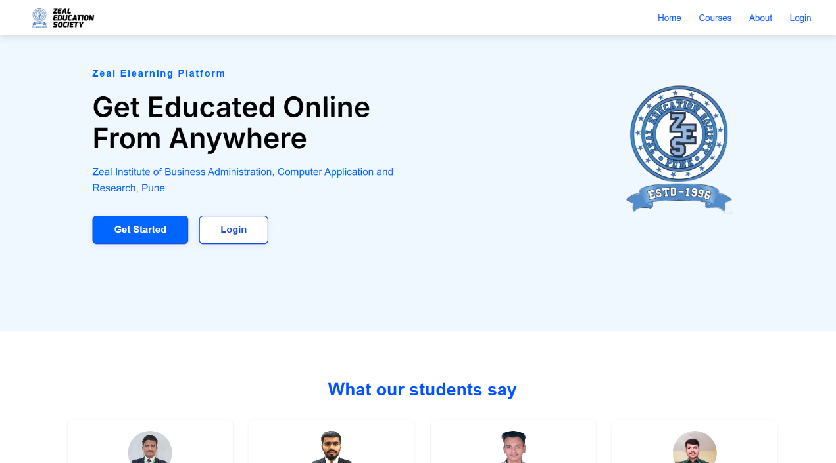

**Screen Name:** About Us

* **Purpose/Use Case:** Provides information about the institution and the platform’s mission.
* **How to Use:** Read the content to understand the background and values of the platform and institution.
* **What it Facilitates:** Builds trust and transparency for users.
* **Validations:** None.

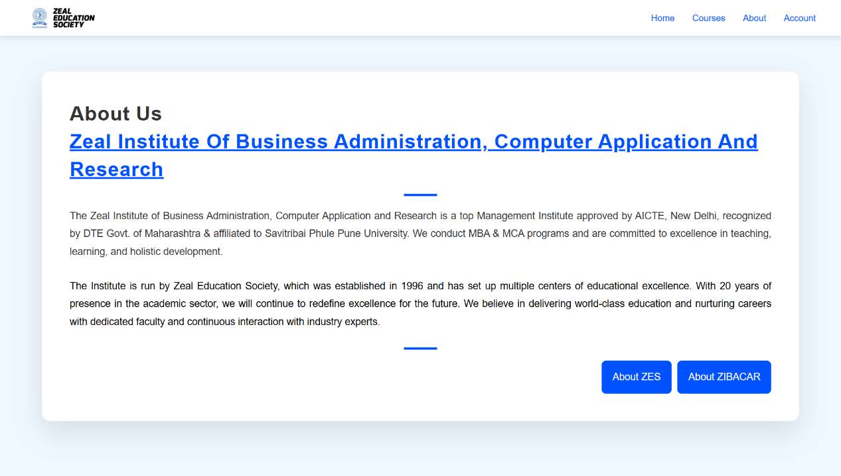

**Screen Name:** Registration

* **Purpose/Use Case:** Allows new users to sign up for the platform.
* **How to Use:** Fill in all required fields (Name, Email, Password, Confirm Password, College, Department, Mobile Number, ZPRN, Date of Birth) and click “Register.”
* **What it Facilitates:** Account creation and onboarding.
* **Validations:**
  + Email: Must be valid and unique
  + Password: Minimum 8 characters, includes uppercase, lowercase, number, special character
  + Confirm Password: Must match Password
  + Mobile Number: 10 digits
  + ZPRN: Valid alphanumeric
  + Date of Birth: Valid date
  + All fields required

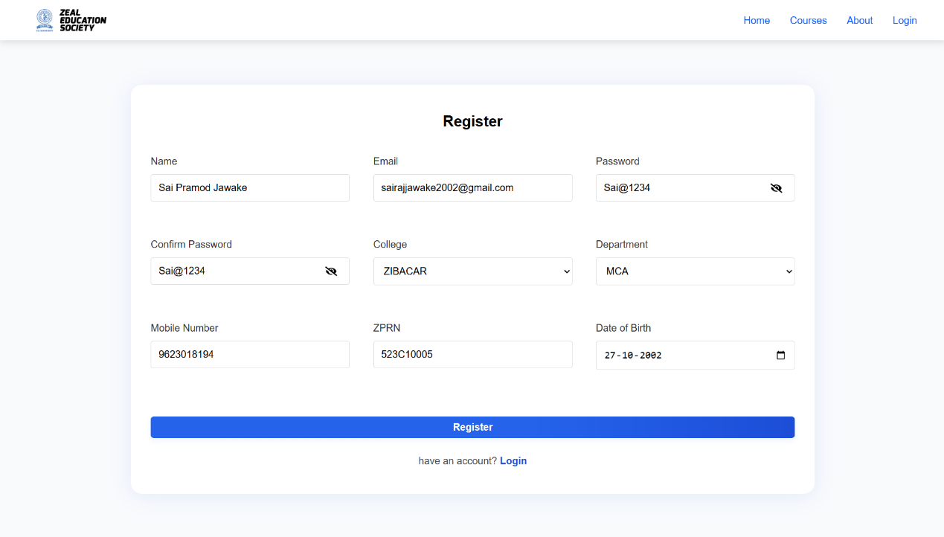

**Screen Name:** Login

* **Purpose/Use Case:** Allows registered users to access their accounts.
* **How to Use:** Enter your registered email and password, then click “Login.”
* **What it Facilitates:** Secure access to user dashboard and courses.
* **Validations:**
  + Email: Must be registered and in valid format
  + Password: Must match the registered password
  + Both fields required

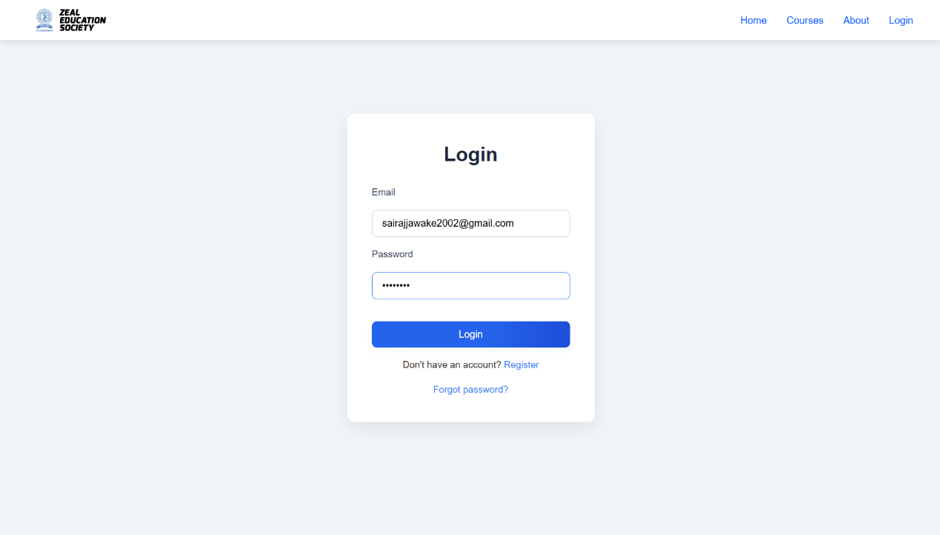

**Screen Name:** Forgot Password

* **Purpose/Use Case:** Enables users to reset their password if forgotten.
* **How to Use:** Enter your registered email and click “Forgot Password” to receive a reset link via email.
* **What it Facilitates:** Password recovery and account security.
* **Validations:** Email: Must be registered and in valid format

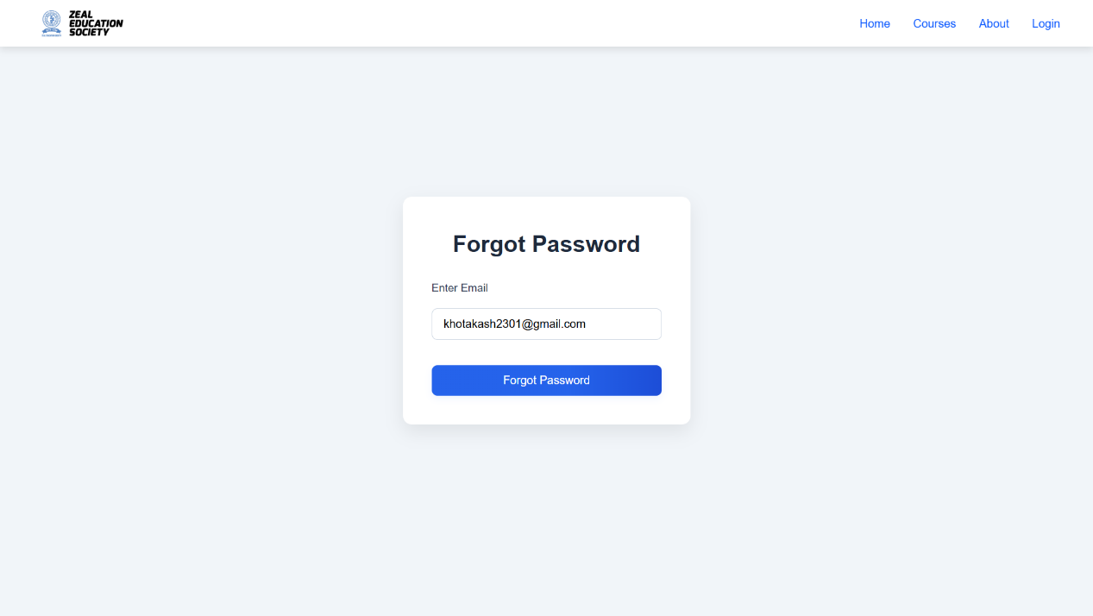

**Screen Name:** OTP Verification

* **Purpose/Use Case:** Verifies user email during registration or password reset.
* **How to Use:** Enter the OTP received via email and submit to complete verification.
* **What it Facilitates:** Secure account activation and password reset.
* **Validations:** OTP: Must be a valid 6-digit code sent to the user’s email. Expires after a set time.

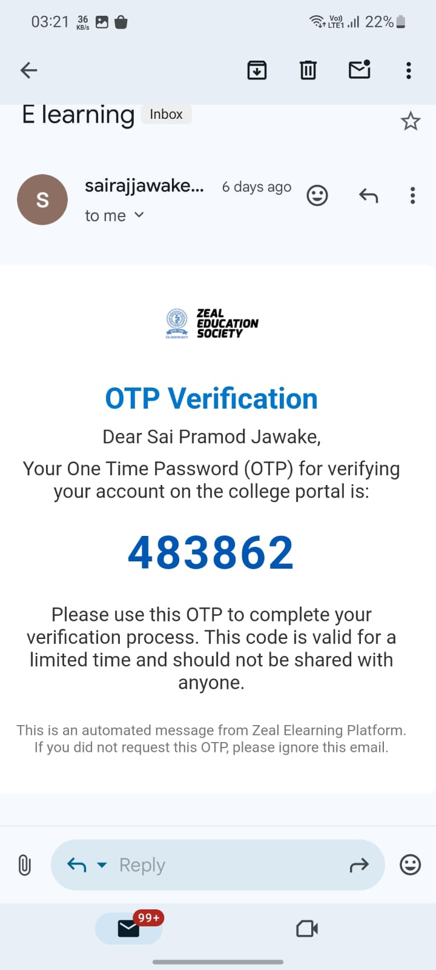

**Screen Name:** Password Reset

* **Purpose/Use Case:** Allows users to set a new password after requesting a reset.
* **How to Use:** Click the link in your email, enter a new password, confirm it, and submit.
* **What it Facilitates:** Regain access to your account.
* **Validations:**
  + Password: Minimum 8 characters, includes uppercase, lowercase, number, special character
  + Confirm Password: Must match Password
  + Both fields required

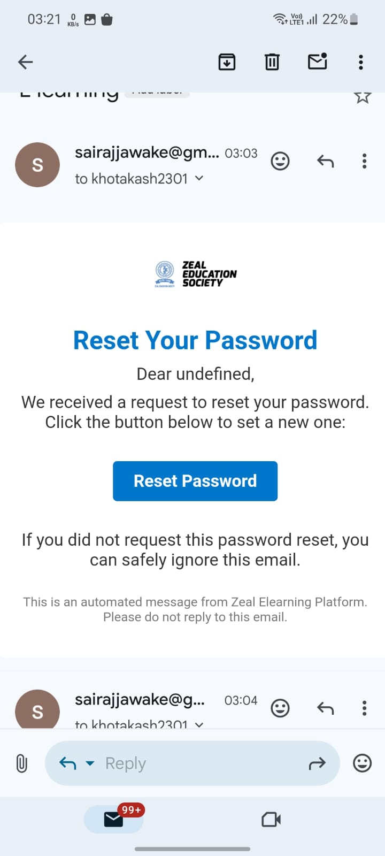

**Screen Name:** Dashboard (User)

* **Purpose/Use Case:** Central hub for accessing all user functionalities.
* **How to Use:** Use the sidebar or dashboard buttons to navigate to different modules such as courses, certificates, and profile.
* **What it Facilitates:** Quick access to all platform features.
* **Validations:** None.

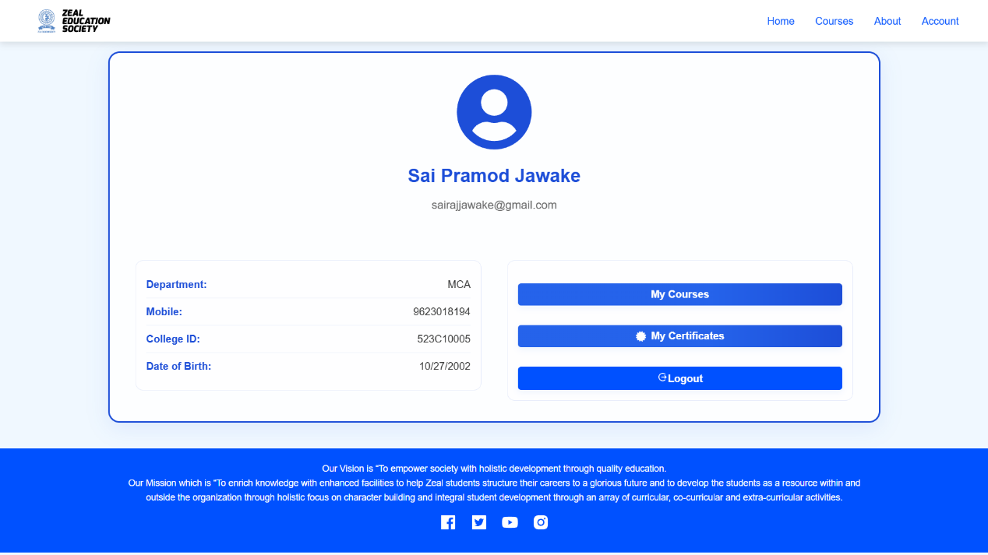

**Screen Name:** Dashboard (Admin)

* **Purpose/Use Case:** Central hub for accessing all admin functionalities.
* **How to Use:** Use dashboard widgets and navigation to manage users, courses, sales, lectures, and certificates.
* **What it Facilitates:** Efficient platform administration.
* **Validations:** None.

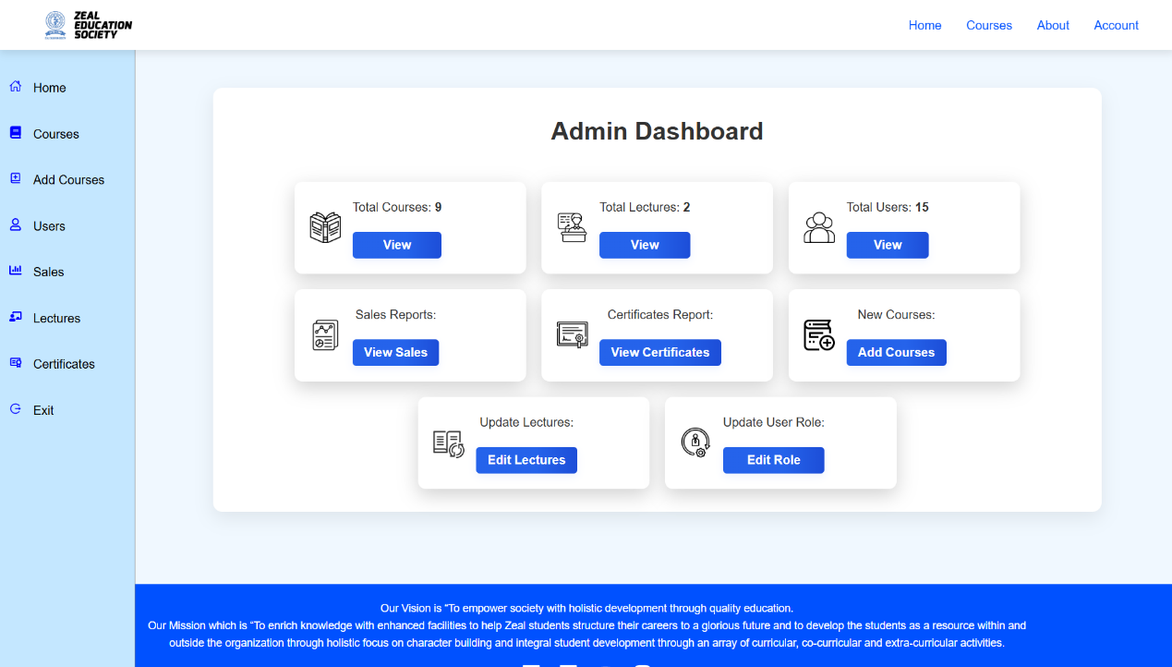

**Screen Name:** Course Catalog

* **Purpose/Use Case:** Displays all available courses for browsing and enrollment.
* **How to Use:** Use the search bar or category filters to find courses. Click on a course card for more details.
* **What it Facilitates:** Course discovery and selection.
* **Validations:** None.

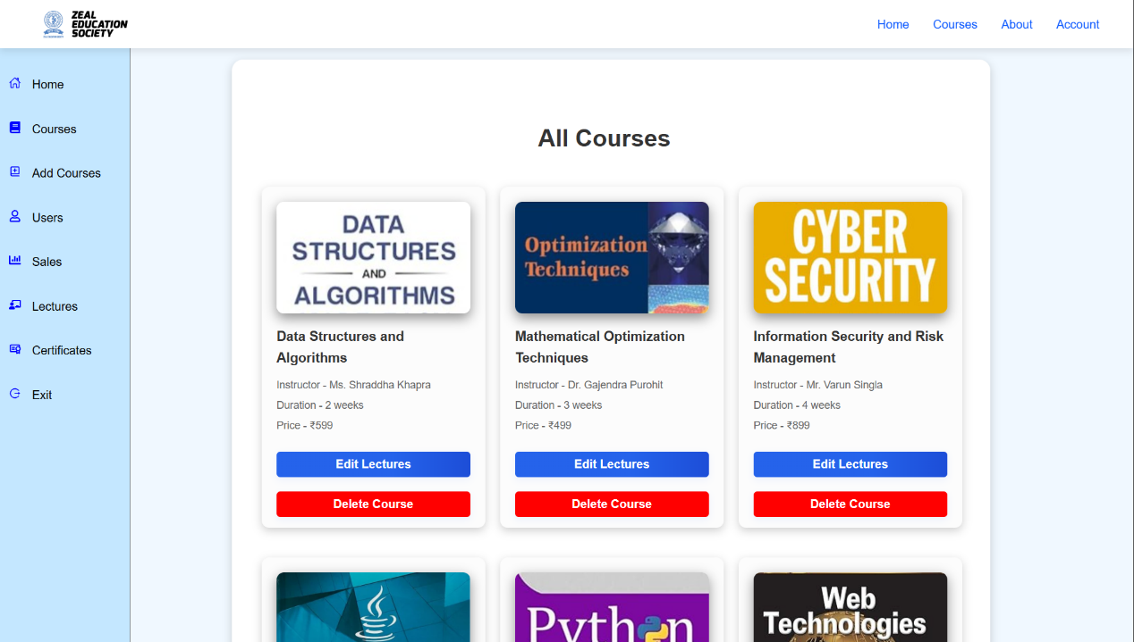

**Screen Name:** Course Details

* **Purpose/Use Case:** Shows detailed information about a selected course.
* **How to Use:** Review course syllabus, instructor, price, and duration. Click “Buy Now” to purchase or “Get Started” to enroll (if free).
* **What it Facilitates:** Informed course enrollment.
* **Validations:** None.

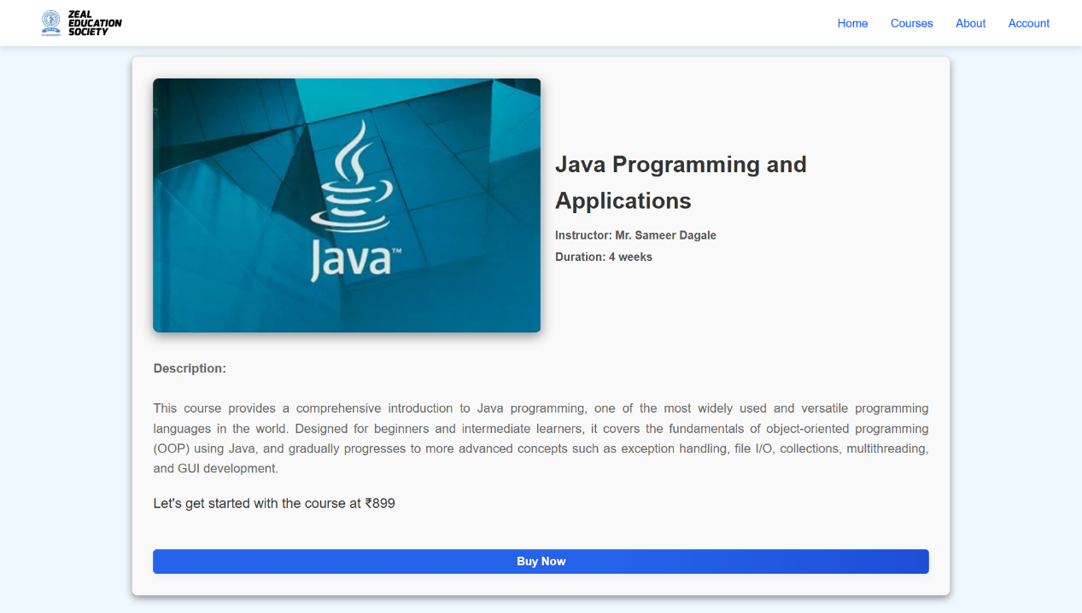

**Screen Name:** Checkout/Payment

* **Purpose/Use Case:** Handles course purchase transactions.
* **How to Use:** Review order summary, select payment method (UPI, Card, Netbanking, Wallet), and complete payment.
* **What it Facilitates:** Secure and convenient payment processing.
* **Validations:**
  + Payment details must be valid and complete
  + Duplicate purchase prevention

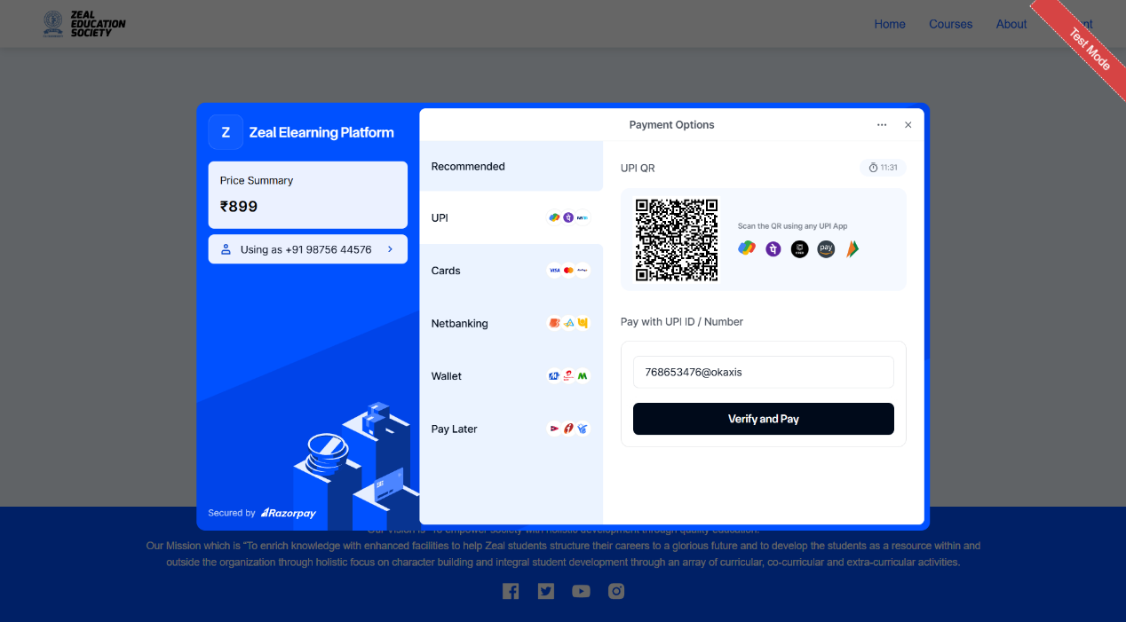

**Screen Name:** My Courses

* **Purpose/Use Case:** Lists all courses the user is enrolled in.
* **How to Use:** Click on a course to start or continue learning.
* **What it Facilitates:** Easy access to purchased/enrolled courses.
* **Validations:** None.

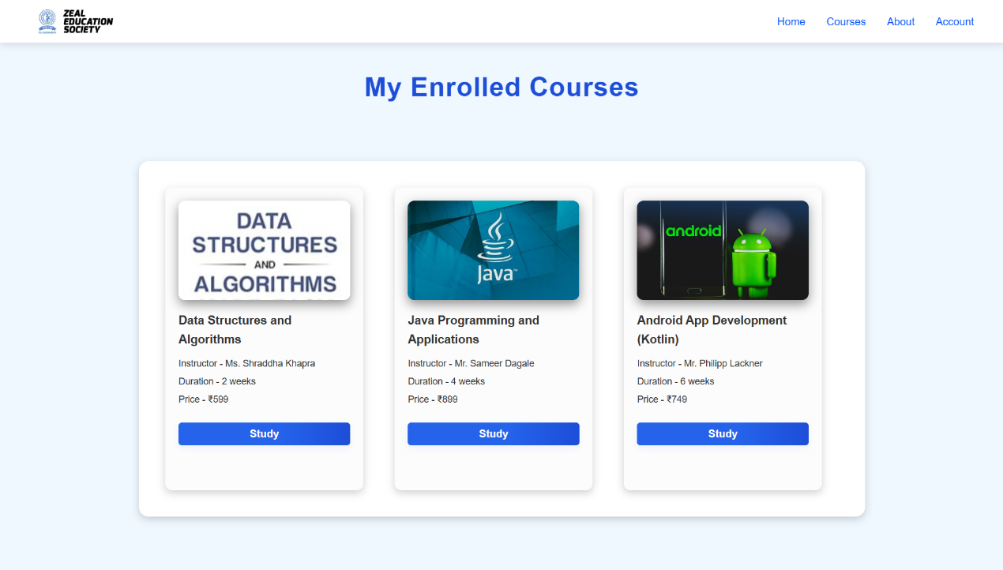

**Screen Name:** Course Player

* **Purpose/Use Case:** Delivers video lectures and course content.
* **How to Use:** Play the video, read lecture notes, and mark as complete.
* **What it Facilitates:** Interactive learning and progress tracking.
* **Validations:** None.

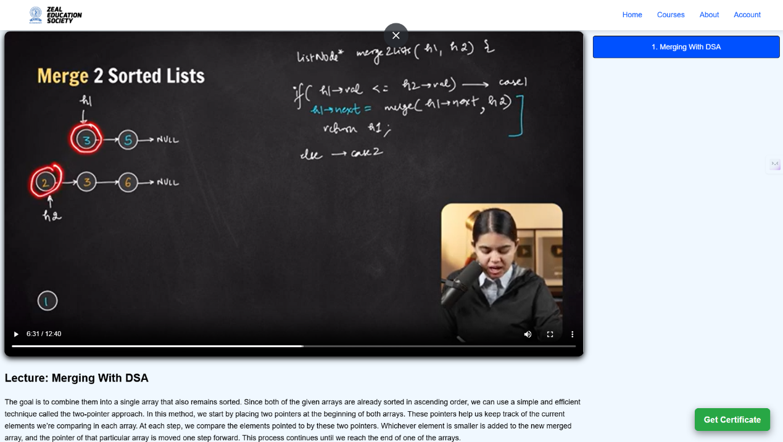

**Screen Name:** Lecture Details

* **Purpose/Use Case:** Displays information about a specific lecture.
* **How to Use:** Read the lecture description and objectives.
* **What it Facilitates:** Deeper understanding of the lecture topic.
* **Validations:** None.



**Screen Name:** Certificate List

* **Purpose/Use Case:** Shows all certificates earned by the user.
* **How to Use:** Click on a certificate to view, download, or share.
* **What it Facilitates:** Proof of achievement and course completion.
* **Validations:** None.

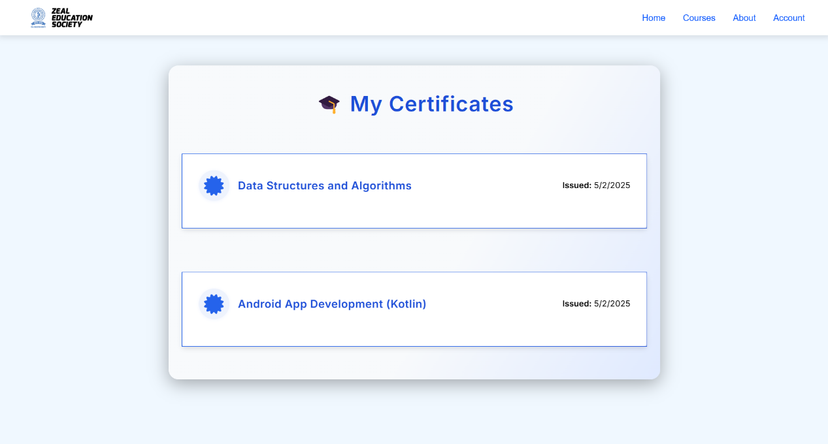

**Screen Name:** Certificate Details

* **Purpose/Use Case:** Displays detailed information about a specific certificate.
* **How to Use:** View certificate details, download as PDF, or share.
* **What it Facilitates:** Verification and sharing of achievements.
* **Validations:** None.

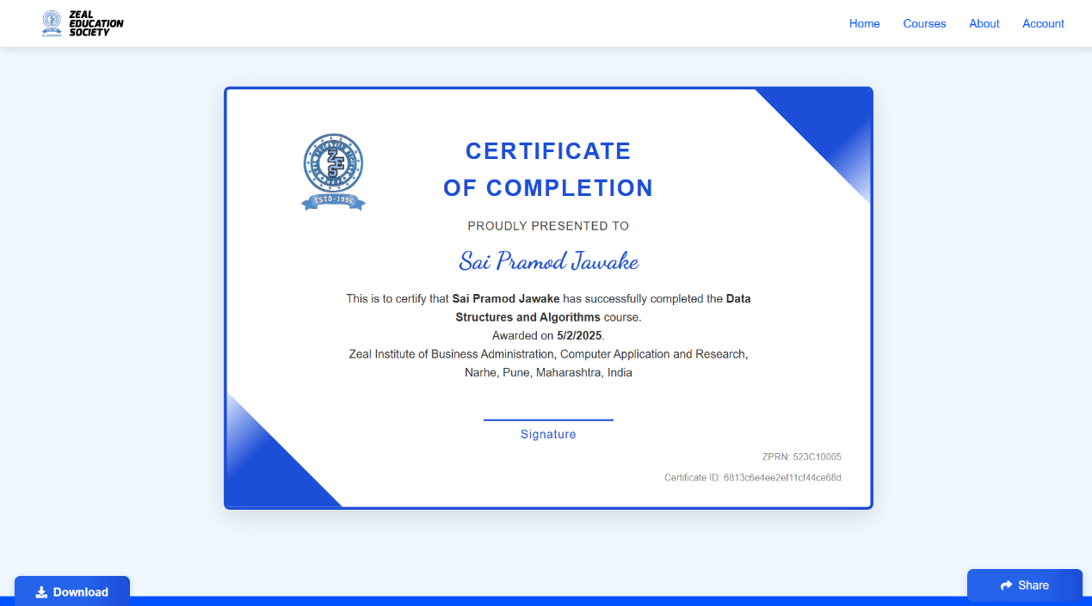

**Screen Name:** Certificate Verification

* **Purpose/Use Case:** Allows users or third parties to verify the authenticity of a certificate.
* **How to Use:** Enter the certificate ID and check the status.
* **What it Facilitates:** Authenticity check and validation.
* **Validations:** Certificate ID must be valid

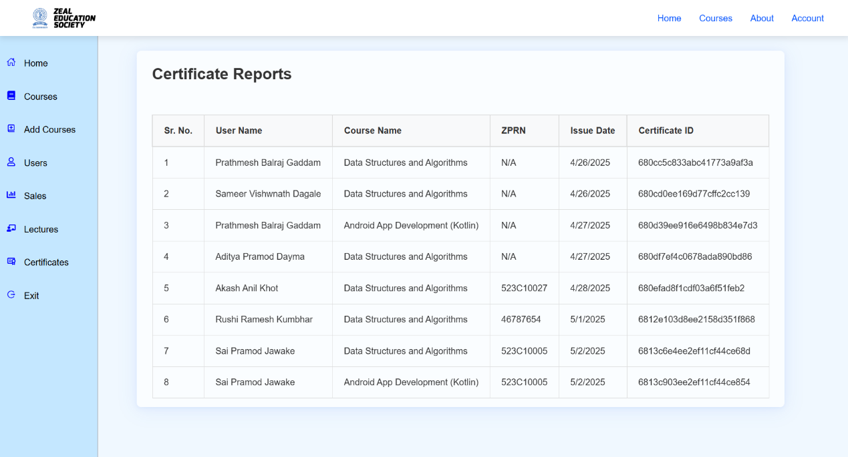

**Screen Name:** Admin: Add Course

* **Purpose/Use Case:** Allows admins to create new courses.
* **How to Use:** Fill in course details, upload an image, and save.
* **What it Facilitates:** Expanding course offerings.
* **Validations:**
  + Title, description, category, duration, and price are required
  + Image is optional

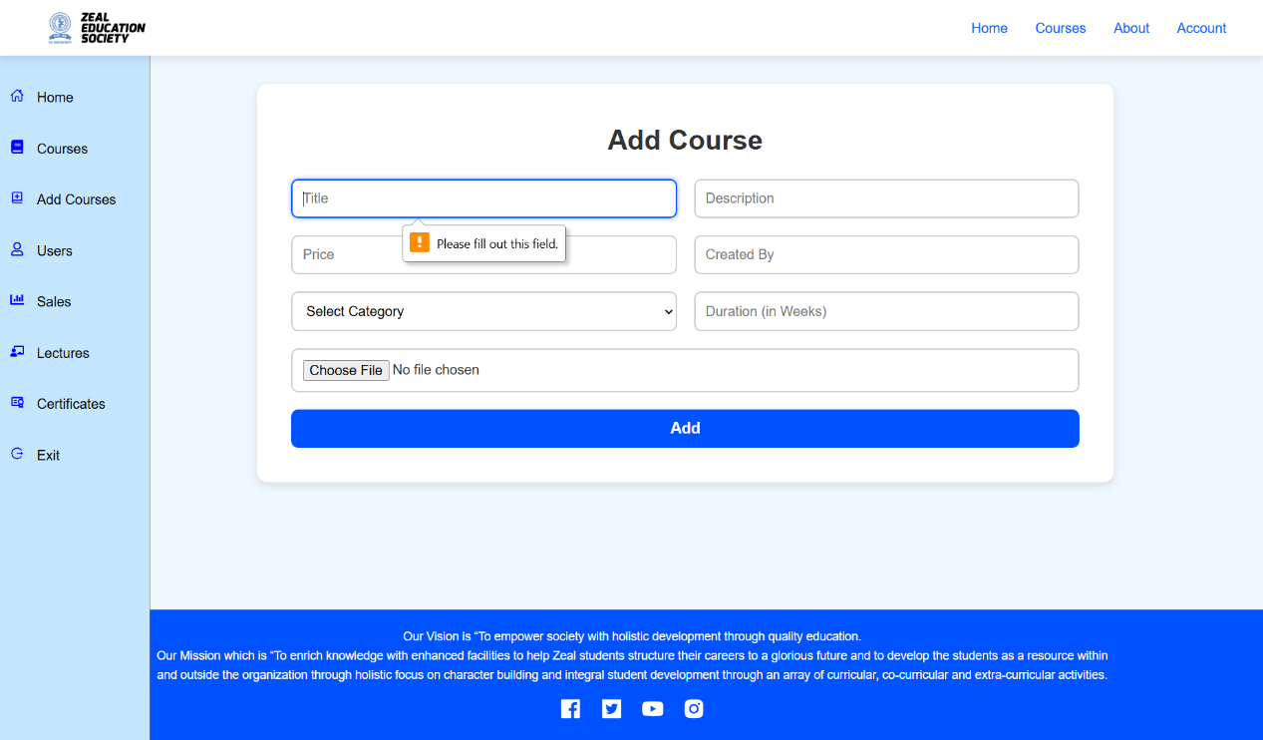

**Screen Name:** Admin: Edit Course

* **Purpose/Use Case:** Allows admins to update existing course information.
* **How to Use:** Edit the desired fields and save changes.
* **What it Facilitates:** Maintaining accurate and up-to-date course information.
* **Validations:** Same as add course



**Screen Name:** Admin: Add Lecture

* **Purpose/Use Case:** Allows admins to add new lectures to a course.
* **How to Use:** Enter lecture title, description, upload video, and save.
* **What it Facilitates:** Content management and course enrichment.
* **Validations:**
  + Title and description required
  + Video required for video lectures

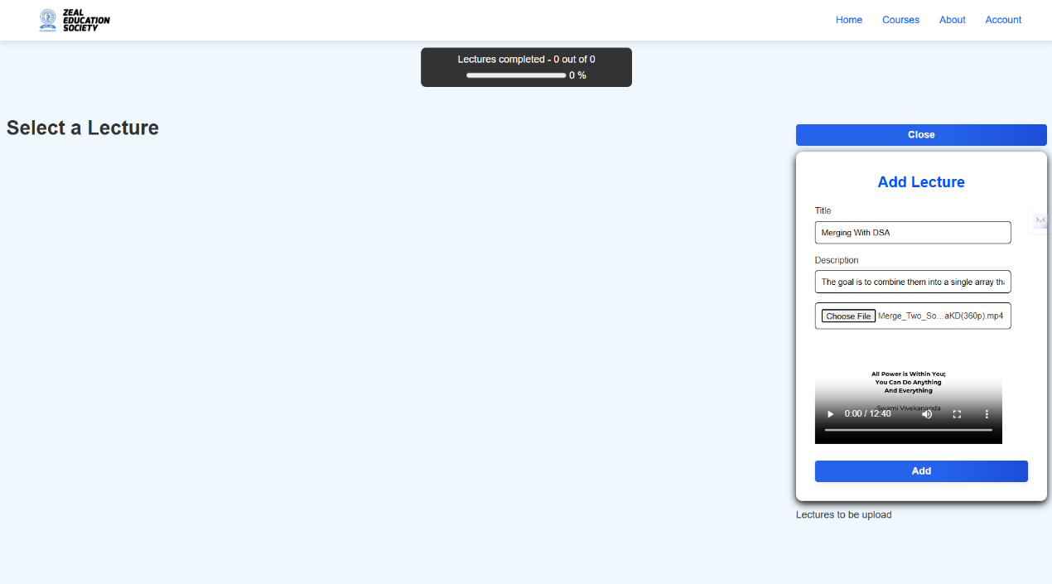

**Screen Name:** Admin: User Management

* **Purpose/Use Case:** Allows admins to manage users and their roles.
* **How to Use:** View the user list, update roles, and manage access.
* **What it Facilitates:** Access control and user administration.
* **Validations:** None.

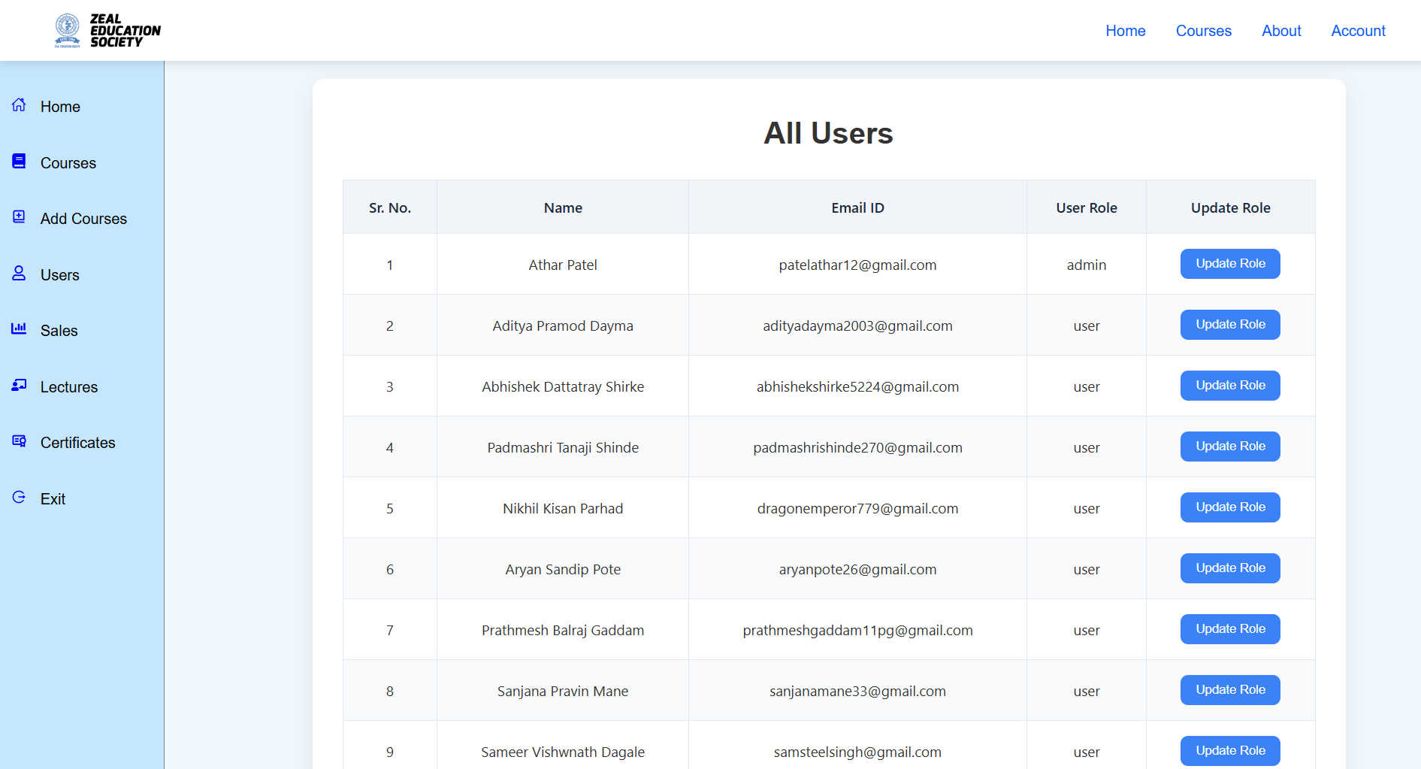

**Screen Name:** Admin: Sales/Reports

* **Purpose/Use Case:** Displays sales and analytics data for the platform.
* **How to Use:** View sales charts, transaction history, and analytics reports.
* **What it Facilitates:** Data-driven decision making and performance monitoring.
* **Validations:** None.

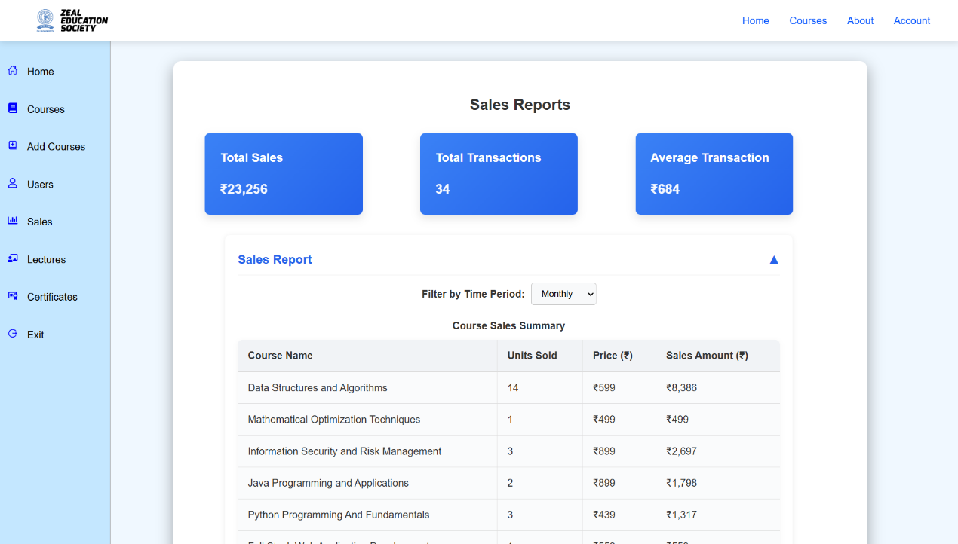

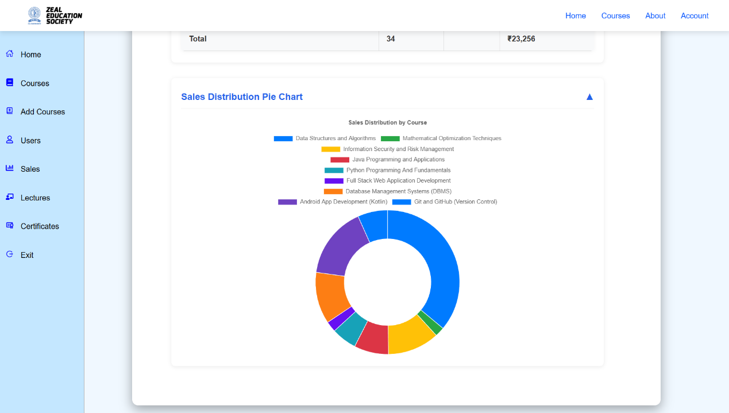

**Screen Name:** Admin: Certificate Reports

* **Purpose/Use Case:** Shows issued certificates and their details for admin review.
* **How to Use:** View, search, and filter certificate records.
* **What it Facilitates:** Certificate management and verification.
* **Validations:** None.

